# Request for Proposals: BME 580.670-671 “Precision Care Design Studio”

## Template:

**Project Title: Advanced Risk Stratification and Prediction of Venous Thromboembolism in Critically Ill Patients**

**Problem Statement**: In one paragraph describe the clinical problem which you propose to address with this project. Specific reference should be made to how data will be used to develop the project solution.

Venous thromboembolism (VTE) is a common preventable cause of harm with potentially life-threatening consequences. The major contributors to VTE disease are deep venous thrombosis (DVT) and pulmonary embolism (PE). In a 2008 report, the Surgeon General of the United States estimated that DVT and PE account for greater than 100,000 deaths/year and called for major efforts to improve the prevention, diagnosis, and treatment of VTE.1 In spite of improvements in the prophylaxis and treatment for VTE the incidence of the disease has increased and diagnosis remains highly challenging (Figure 1). 2

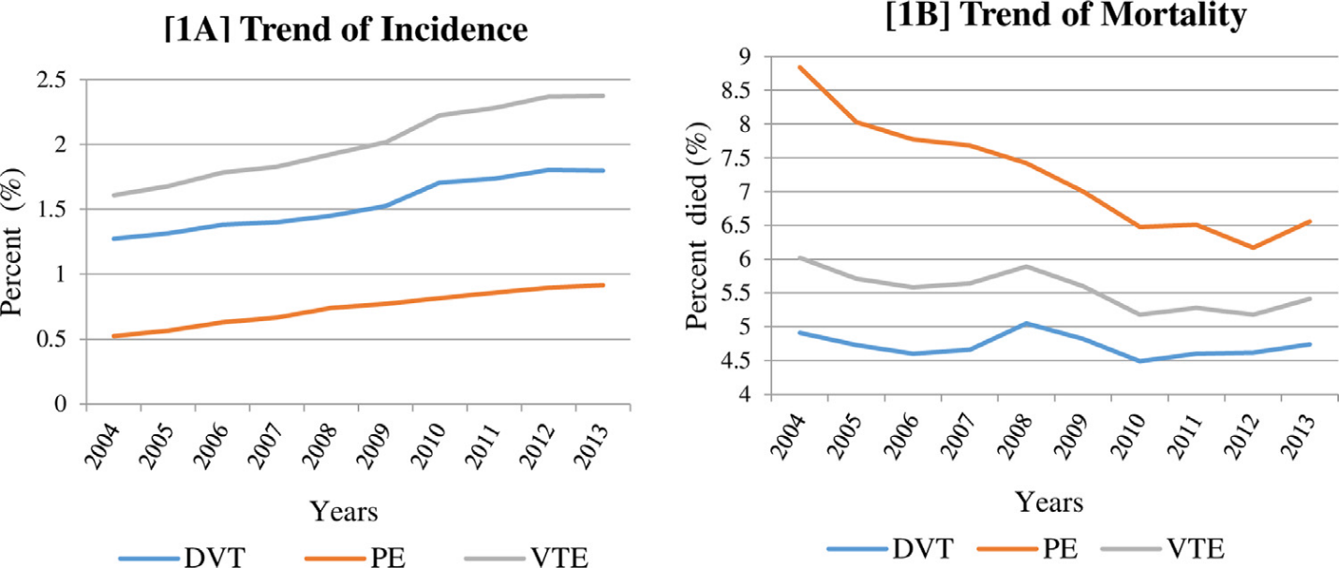

A number of models to stratify risk of VTE are in clinical use and these tools help clinicians to determine the intensity and duration of prophylactic therapies. In spite of the compelling need to assess risk of VTE there is no standardized risk assessment model for VTE in hospitalized patients. 3 For the vast majority of ICU patients, some combination of pharmacologic prophylaxis and/or mechanical prophylaxis is standard therapy. Despite these tools and standard clinical therapies, the incidence in medical-surgical ICUs is estimated to be almost 10%.4 Equally troubling, is that diagnosis of VTE in critically ill patients often occurs at a late stage of disease. This is because the initial onset of disease is often asymptomatic, and the current diagnostic approach to VTE is dependent on patient reported symptoms combined with physiologic parameters (such as HR, BP, and oxygen saturation) obtained from low frequency monitoring. Diagnostic tools, such as the Wells Score have poor sensitivity in the critically ill. Conversely, anticoagulant therapies for VTE prevention and treatment are associated with increased risk of bleeding, which can be particularly problematic in critically ill surgical patients. We hypothesize that integration of minute to minute physiologic data with standard clinical predictors of VTE risk can produce a more sensitive and specific tool for risk assessment and early diagnosis of VTE. We further hypothesize that this tool can improve VTE treatment by allowing physicians to apply therapy in a manner more consistent with its risk: benefit ratio.

Figure 1. Trends of incidence (A) and mortality (B) of inpatient venous thromboembolism (VTE), deep vein thrombosis (DVT), and pulmonary embolism (PE) in United States from 2004 to 2013. Abbreviations: DVT = deep vein thrombosis; PE = pulmonary embolism; VTE = venous thromboembolism. (From Mehta et al 2019)

**Project Team:** Identify key personnel and their roles (eg. Mentor, co-Investigator, research associate, etc.)

1) Adam Sapirstein, MD (Mentor) -. Dr. Sapirstein is an expert in critical care medicine and is the immediate past director of the division of Adult Critical Care in ACCM. He will oversee the clinical data requests and IRB submissions. He has been the PI on an AHRQ Patient Safety Learning Lab P30 grant and a co-investigator on the Emerge project to eliminate preventable harms in the ICU. These projects have established relationships with teams at the Armstrong Institute and the Applied Physics Lab. Dr. Sapirstein is also the Director of the Division of Informatics, Integration, and Integration for ACCM and charged with developing capacity for informatics-based education, research, and care innovations.

2) Nauder Faraday, MD MPH (Co-Investigator) - Dr. Faraday is an expert in critical care medicine and is the past Director of Cardiac Surgical ICU. He and Dr. Sapirstein have worked closely together on care delivery issues in the ICU for the past 18 years. Dr. Faraday is currently the Director of the Clinical Research Core for ACCM and has a direct supervisory role for personnel involved in clinical data collection and analysis for Q/I and research purposes. Dr. Faraday is an expert in hemostasis and thrombosis with continuous research funding from the NIH for the past 20 years. One of the aims of his research program is to identify novel clinical and molecular factors that allow precision guided therapy to critically ill and injured patients.

3) Sachin Hebbar, PhD. (Co-Investigator) Dr Hebbar is currently Sr. Research Data Manager for the CRC in ACCM with adjunct appointment in the CCDA. Dr. Hebbar is responsible for extraction, storage, and management of clinical data from ACCM used in Q/I and research projects. He has substantial expertise in database manipulation and programming (SQL, JAVA, R, SAS), operating systems (Windows, UNIX, LINUX), web development (C#, HTML, XML), and modeling/reporting tools (TFS, SpotFire, Tableau, MS Office, Visio, SSRS).

**Background**: Describe the current state of research and practice as it relates to the proposal. Estimates of the impact of a successful project will be helpful. (No more than 1 page).

VTE disease is a compelling case for using data to both prevent and diagnose a disease. A recent review points out that VTE is the third most common cardiovascular disease but clinicians are faced with the conflicting goals of preventing VTEs while not over-treating patients. 5, 6 Prophylaxis of VTE is routinely performed in hospitalized patients by the intermittent administration of heparin and the application of sequential mechanical compression stockings. This prophylaxis is not entirely effective and the best approach remains in evolution.7, 8 Thus, there is a pressing need to both identify patients at greatest risk of developing VTE and also to diagnose those that do have the disease.

The current approach to diagnosis of VTE is based on suspicion of the disease (prior probability) triggering a diagnostic exam. For patients in the surgical ICU the prior probability of VTE at baseline is extremely high because cancer, trauma, immobility, and inflammation are well documented risk factors. The signs and symptoms that are routinely used as indicators of VTE are relatively non-specific and commonly occur in ICU patients without VTE. These include leg swelling, difficulty with ventilation, fever, rapid heart rate, and low blood pressures. A standard lab test – D-dimer- is essentially non-diagnostic for surgical ICU patients. As a result the decision to pursue a diagnostic test, that may carry risk and costs, is neither sensitive nor specific in our patient populations.4 While physiologic trends, underlying disease states, patient characteristics, and therapies can all be known, they are not integrated in a meaningful way into an accurate risk scoring or prediction model.

**Potential Solution:** Describe your vision of the result of the student team’s work.

In this project we propose to create a new clinical decision support tool to predict VTE. The target population for this project will be the surgical intensive care unit (SICU) and Weinberg Intensive Care Unit (WICU) in which patients are at high risk for and are frequently administered anticoagulants for prevention and/or treatment of VTE. While there have been some attempts to use advanced analytic techniques such as machine learning to assess VTE risk, there is no model that uses near real time physiologic data for the detection of VTE disease in its earliest stages. We postulate that a patient’s state (disease, surgery, medications, activity, demographics, etc) and physiologic trends can be analyzed to determine their risk of developing VTE. The project goal is to develop an advanced VTE state detection system. Such a real-time analysis system will have a significant impact on our ability 1) to identify the highest risk patients for whom more intensive prophylactic therapy is required; 2) to detect VTE at the earliest stages of disease, enabling earlier intervention that can prevent catastrophic consequences of VTE, and, 3) create predictive analytic tools that allow precision delivery of VTE therapies in accordance with the risk-benefit profiles for individual patients.

**Preliminary Data/Relevant Experience**: Include any preliminary data that you may already have that relates to the proposal. Please indicate if you have specific experience or education that enhances your ability as a project mentor.

Our research team includes the Clinical Research Core (CRC) from the ACCM Department. Personnel in the CRC have the data management and statistical expertise to manage and analyze EHR data for Q/I and research projects and are currently involved in many such projects in our department.

In addition over the last year we conducted a preliminary feasibility analysis to determine the number of patients in our ICUs that suffer a VTE. Using ICD10 codes we examined data from 2016- 2017 and found that ~ 2% (n=231) of the surgical ICU patients have a VTE diagnosis within 24 hours. Given this number of patients that can be characterized as “true positives” for the disease state it should be possible to develop a feature set that can be prospectively tested in future investigations.

**Data Set Identification**: Indicate the data sets or a brief synopsis of elements that you believe will be needed to develop the proposed project. Examples could include physiologic data from OR and ICU monitors, narrative elements from Epic, data from hospital finance systems, etc.

As part of ongoing quality improvement efforts in the department of Anesthesiology, data can be obtained from adult patients who have undergone surgery at Johns Hopkins Hospital and were admitted to one of the surgical intensive care units (SICU, WICU, CVSICU, NCCU). Data available from the EHR include: admitting diagnoses (ICD10 codes), hospital procedures (ICD10 and CPT codes), physiologic data (e.g. blood pressure, heart rate and rhythm, respiratory rate, oxygen saturation, oxygen delivery method, white cell count, trauma), intake and output (e.g. intravenous fluids, blood products, urine output), laboratory data, medications and hospital unit location, throughout the hospital stay.

**Other Supporting Information**: Please include letters from co-investigators or other information that you believe support your application.

**References:** Please include no more than 10 references that support your proposal.

1. United States. Public Health Service. Office of the Surgeon General. *The Surgeon General's call to action to prevent deep vein thrombosis and pulmonary embolism*. Rockville, MD: U.S. Public Health Service, Office of the Surgeon General, 2008, p.ii, 42 p.

2. Mehta KD, Siddappa Malleshappa SK, Patel S, et al. Trends of Inpatient Venous Thromboembolism in United States Before and After the Surgeon General's Call to Action. *Am J Cardiol* 2019. DOI: 10.1016/j.amjcard.2019.06.015.

3. Stuck AK, Spirk D, Schaudt J, et al. Risk assessment models for venous thromboembolism in acutely ill medical patients. A systematic review. *Thromb Haemost* 2017; 117: 801-808. 2017/02/06. DOI: 10.1160/th16-08-0631.

4. Cook D, McMullin J, Hodder R, et al. Prevention and diagnosis of venous thromboembolism in critically ill patients: a Canadian survey. *Crit Care* 2001; 5: 336-342. 2001/09/26.

5. Righini M, Robert-Ebadi H and Le Gal G. Diagnosis of acute pulmonary embolism. *J Thromb Haemost* 2017; 15: 1251-1261. 2017/07/04. DOI: 10.1111/jth.13694.

6. Kotaska A. Venous thromboembolism prophylaxis may cause more harm than benefit: an evidence-based analysis of Canadian and international guidelines. *Thromb J* 2018; 16: 25. 2018/10/10. DOI: 10.1186/s12959-018-0180-6.

7. Anderson DR, Dunbar M, Murnaghan J, et al. Aspirin or Rivaroxaban for VTE Prophylaxis after Hip or Knee Arthroplasty. *N Engl J Med* 2018; 378: 699-707. DOI: 10.1056/NEJMoa1712746.

8. Arabi YM, Al-Hameed F, Burns KEA, et al. Adjunctive Intermittent Pneumatic Compression for Venous Thromboprophylaxis. *N Engl J Med* 2019; 380: 1305-1315. 2019/02/18. DOI: 10.1056/NEJMoa1816150.